**Section 2.4 Graphical Misrepresentations of Data**

**Objective**

1. Describe What Can Make a Graph Misleading or Deceptive

***Objective 1: Describe What Can Make a Graph Misleading or Deceptive***

Objective 1, Page 1

*Answer the following after watching the video.*

1. Explain the difference between a graph that is misleading and a graph that is deceiving.
2. List what the most common misrepresentations of data involve.

* Increments between tick marks should be consistent.
* Scales for comparative graphs should be the same.
* The baseline, or zero point, should be at the bottom of the graph.

Objective 1, Page 2

**Example 1 *Misrepresentations of Data***

A home security company located in Minneapolis, Minnesota, develops a summer ad campaign with the slogan "When you leave for vacation, burglars leave for work." According to the city of Minneapolis, roughly 20% of home burglaries occur during the peak vacation months of July and August. The advertisement contains the graphic shown. Explain what is wrong with the graphic.

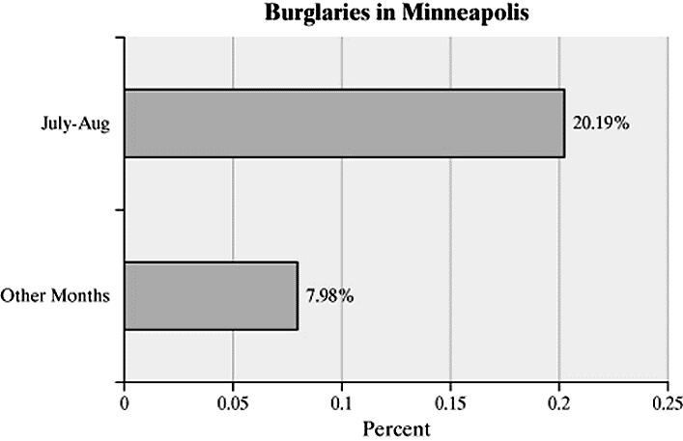

Objective 1, Page 3

**Example 2 *Misrepresentations of Data by Manipulating the Vertical Scale***

A national news organization developed the following graphic to illustrate the change in the highest marginal tax rate effective January 1, 2013. Why might this graph be considered misleading?

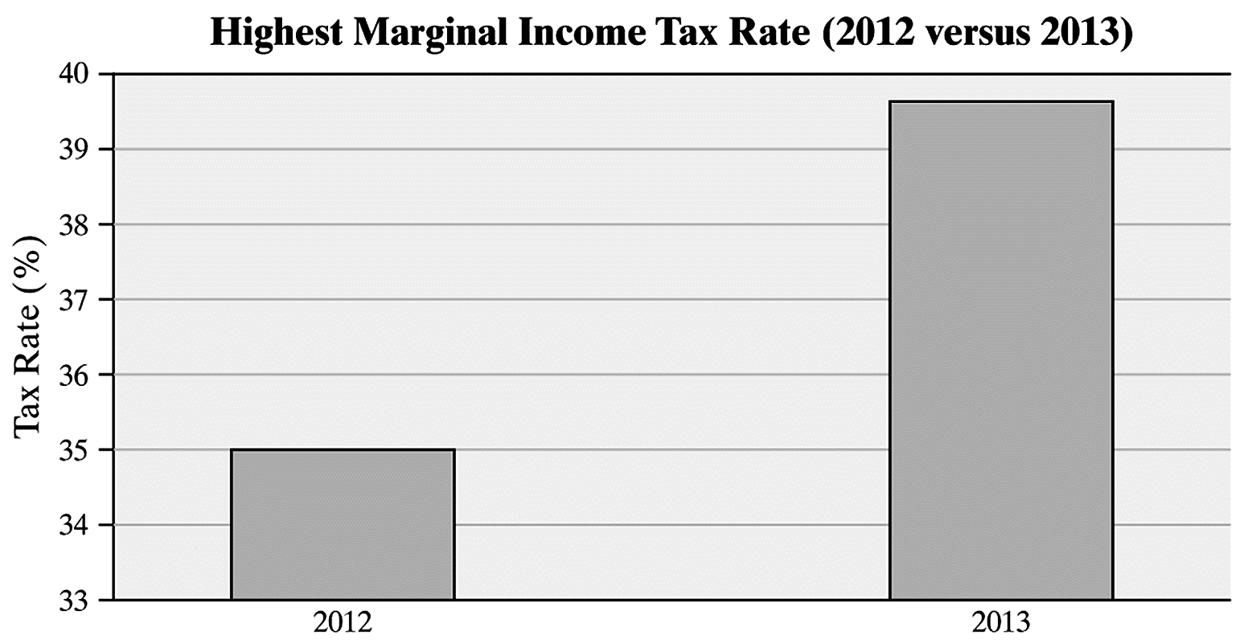

Objective 1, Page 5

**Example 3 *Misrepresentations of Data by Manipulating the Vertical Scale***

The graph depicts the number of residents in the United States living in poverty. Why might this graph be considered misrepresentative?

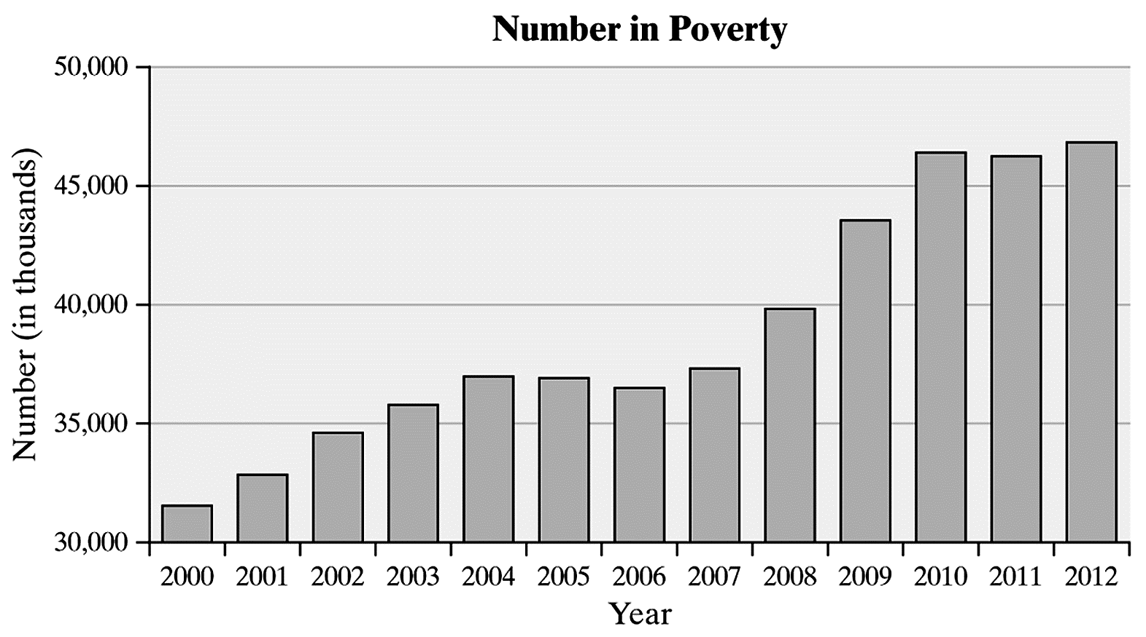

Objective 1, Page 7

**Example 4 *Misrepresentations of Data***

The bar graph shown is a *USA Today*-type graph. A survey was conducted by Impulse Research in which individuals were asked how they would flush a toilet when the facilities are not sanitary. What is wrong with the graphic?



Objective 1, Page 9

1. Why is the use of 3-D effects strongly discouraged?
2. Why do we emphasize that the bars or classes should have the same width?

Objective 1, Page 10

**Example 5 *Misrepresentations of Data by Manipulating Dimension***

Soccer continues to grow in popularity as a sport in the United States. In 1991, there were approximately 10 million participants in the United States aged 7 years and older. By 2009, this number had climbed to 14 million. To illustrate this increase, we could create a graphic like the one shown below. Describe how the graph may be misleading. *Source:* U.S. Census Bureau; National Sporting Goods Association

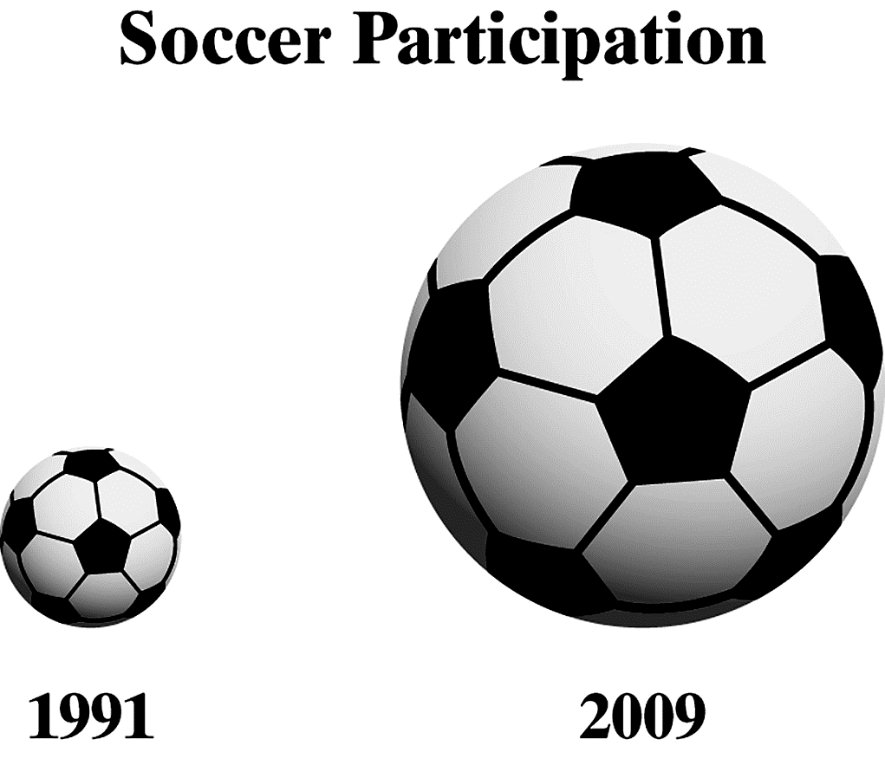

Objective 1, Page 11

**Example 6 *Misrepresentations of Data: Three-Dimensional Scale***

The figure represents the educational attainment (level of education) in 2016 of adults 25 years and older who are U.S. residents. Why might this graph be considered misrepresentative?

